**NOAA Ship THOMAS JEFFERSON Procedure Document**

Procedure:

**Side scan telemetry adjustments and setting pressure sensor offset.**

Creation Date:

8/31/2020

Revision Date:

Software used:

Sonarpro, Notepad, Linux TPU Updater

Procedure Number:

**TBD**

Approved:

**TBD**

# Overview and Scope

How to set your Preemphasis, LBOgain, and pressure sensor offset for a well running side scan system.

# Procedure Inputs and Outputs

## Inputs:

## Outputs:

# Procedure

There are many factors that may cause you to have to change the Preemphasis, LBOgain, and pressure sensor offset. The most common one is changing TPU’s between towfish.

There are 2 different methods on how to change these settings depending on what TPU you are using. Either the Black Linux TPU or the Gold TPU of yesteryear. The Black Linux TPU’s are having issues with ping skips so both methods are valid if you find yourself in a similar situation.

Gold TPU Method

**Telemetry errors**

Telemetry errors can manifest in 3 ways with the Gold TPU box.

When you connect to the fish and click  to start the presentation of real time data, the fish itself does not return any data to sonar pro.

You will see a checksum or sensor error in the Error status message window.



The last way telemetry errors can manifest are through the com port connection to the TPU. This is the easiest and fastest way to see telemetry errors with the Gold TPU other than the first manifestation described above. You will see a message in the com terminal such as:

0x1bcf0180 (getDspData): Telemetry Error Count 4

0x1bcf0180 (getDspData): Telemetry Error Count 2

0x1bcf0180 (getDspData): Telemetry Error Count 1

**How to fix Telemetry Errors**

You can “Fix” telemetry Errors by adjusting the Preemphasis and LBOgain. The Gold TPU’s typically take significantly less Preemphasis and LBOgain than the Black Linux TPU’s. The Gold TPU’s are different in that they require a FTP server and the startup INI that sets the Preemphasis and LBOgain to be stored on the PC. With the Black Linux TPU’s the startup INI is stored within the TPU and it does not require an FTP server to be installed on the PC.

You can find the startup INI for the Gold TPU in C:\klein\. It is named and should always be named startup.ini. The Gold TPU when it boots looks for that naming convention. To change the Preemphasis and LBOgain open up the startup INI in a text editor. A good choice is Notepad++. With the startup INI open scroll down till you see:

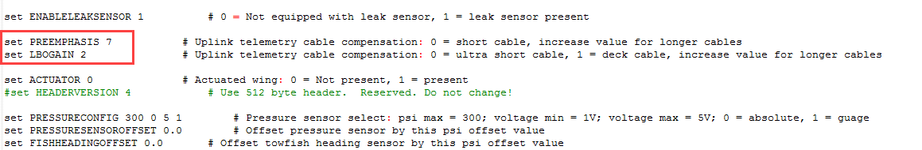

A good value to start at with the Gold TPU is a Preemphasis of 7 and an LBOgain of 2. These values have historically worked with approximately 200m of .525 cable. The max Preemphasis and LBOgain that a Klein TPU can use is 7 and 3 respectively. Each value of LBOgain has a total of 7 Preemphasis values that will give you 21 total combinations. You must adjust the Preemphasis and LBOgain till you are no longer seeing telemetry errors. After reaching max Preemphasis within an LBOgain range add 1 to the LBOgain. If at 3 LBOgain start the next iteration of Preemphasis at 3 or 4. Anything less than 3 or 4 for Preemphasis with an LBOgain of 3 is not going to work.

**Setting pressure sensor offset**

The last thing you need to do for a well running system is to set the pressure sensor offset. The towfish must be sitting on deck in order to know what to set for the offset. With the towfish sitting on deck the pressure sensor should be reading around 14.7 within sonarpro. This value is found in the status indicator within sonar pro on the bottom right of the program.

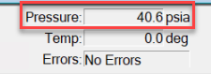

Open the startup INI and scroll down till you see:

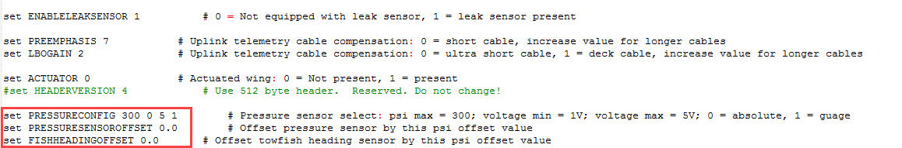

Make sure the PressureConfig is set to 300 0 5 1 before making any adjustments to the pressure sensor offset. This is the typical setting for a 5000, 5000 MKII, or 5000V2 towfish. If it is not, set it, save the INI, and restart the TPU and sonar pro. Wait 45 seconds before turning the TPU back on when restarting in order to allow the capacitors to discharge. This will change your pressure sensor values.

Now that the PressureConfig is set, the towfish is on deck, and SonarPro is open and connected you need to calculate the offset in order for the pressure sensor to read 14.7. Put your value within:

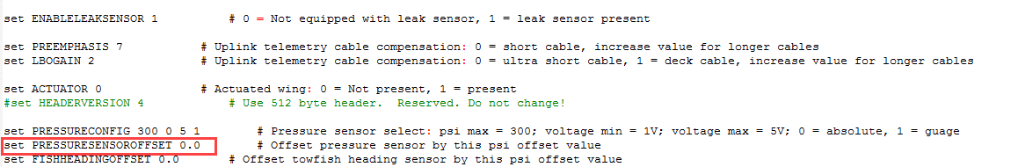

The accuracy can only be to 1 decimal. Negative or positive numbers can be used.

Black Linux TPU Method

**Telemetry errors**

Telemetry errors can manifest in 3 ways with the Black TPU box.

When you connect to the fish and click  to start the presentation of real time data, the fish itself does not return any data to sonar pro.

You will see a checksum or sensor error in the Error status message window.



The last way telemetry errors can manifest are through the Status indicators on the TPU. The ERROR status indicator will flash red every once in a while. If the telemetry errors are really bad you may see the TRIGGER, RESPONDER, and ERROR status indicators flash in unison. This is the easiest and fastest way to see telemetry errors with the black TPU other than the first manifestation described above. See image below.

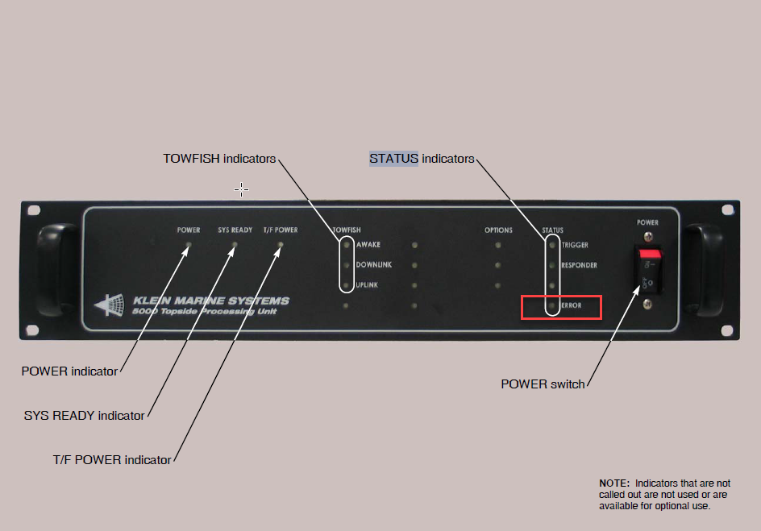

**How to fix Telemetry Errors**

You can “Fix” telemetry Errors by adjusting the Preemphasis and LBOgain. The Gold TPU’s typically take significantly less Preemphasis and LBOgain than the Black Linux TPU’s. The Gold TPU’s are different in that they require a FTP server and the startup INI that sets the Preemphasis and LBOgain to be stored on the PC. With the Black Linux TPU’s the startup INI is stored within the TPU and it does not require an FTP server to be installed on the PC.

You can find the startup INI for the Black TPU by connecting to the TPU with the Linux TPU Updater program found on the PC. The TPU must be up and running with the T/F Power indicator lighted before you can connect to it with the Linux TPU updater program. Open up the Linux TPU Updater program and click the “Default Addr” button. This will input the IP address that you will use to connect to the TPU. See image below.

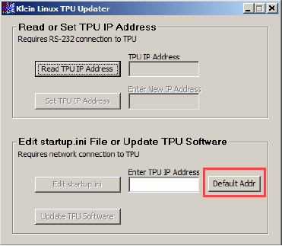

With the default address loaded in click the “Edit startup.ini” button. This will open up the INI that is on the TPU. See image below.

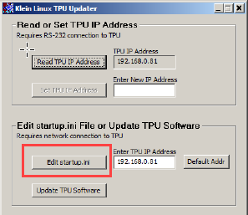

Once it opens the startup.ini you will see a typical klein startup ini in text format. The TPU updater will open up the startup.ini in notepad. To save any changes to the INI on the TPU you must save the INI document in notepad. Clicking the exit button of the notepad program and clicking yes to save at the prompt works to save the ini. When you exit Notepad and have saved changes the system will reboot. Sometimes the system does not reboot and gets “stuck”. At that point you need to manually restart the system. Wait 45 seconds before turning the TPU back on when manually restarting the TPU in order to allow the capacitors to discharge.

With the startup INI open scroll down till you see:



A good value to start at with the Black Linux TPU is a Preemphasis of 4 and an LBOgain of 3. These values have historically worked with approximately 200m of .525 cable. The max Preemphasis and LBOgain that a Klein TPU can use is 7 and 3 respectively. Each value of LBOgain has a total of 7 Preemphasis values that will give you 21 total combinations. You must adjust the Preemphasis and LBOgain till you are no longer seeing telemetry errors. After reaching max Preemphasis within an LBOgain range add 1 to the LBOgain. If at 3 LBOgain start the next iteration of Preemphasis at 3 or 4. Anything less than 3 or 4 for Preemphasis with an LBOgain of 3 is not going to work.

**Setting pressure sensor offset**

The last thing you need to do for a well running system is to set the pressure sensor offset. The towfish must be sitting on deck in order to know what to set for the offset. With the towfish sitting on deck the pressure sensor should be reading around 14.7 within sonarpro. This value is found in the status indicator within sonar pro on the bottom right of the program.



Open the startup INI and scroll down till you see:



Make sure the PressureConfig is set to 300 0 5 1 before making any adjustments to the pressure sensor offset. This is the typical setting for a 5000, 5000 MKII, or 5000V2 towfish. If it is not, set it, save the INI, and restart the TPU and sonar pro. Wait 45 seconds before turning the TPU back on when manually restarting the TPU in order to allow the capacitors to discharge. This will change your pressure sensor values.

Now that the PressureConfig is set, the towfish is on deck, and SonarPro is open and connected you need to calculate the offset in order for the pressure sensor to read 14.7. Put your value within:



The accuracy can only be to 1 decimal. Negative or positive numbers can be used.

# References

N/A